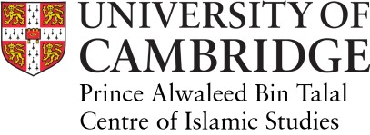
Visiting Researcher Application Form – 2019/20

Application deadline: May 5, 2019
Return to: cis@cis.cam.ac.uk

Last name
First name
Address
Country
Date of Birth
Phone no.
Email

Home Institution
Address
Country
Email
Faculty
e.g. History, Law
Position

Source of funding while in Cambridge:
Privately funded ◻ Other ◻ Please specify:
Proposed date of arrival in Cambridge:
Duration of stay:

Please include the following documents with the application:

- A covering letter addressed to the Director outlining reasons for carrying out research in Cambridge.
- Curriculum vitae
- Research proposal
- Two references (at least one academic).

This form should be returned with the supporting documents to: cis@cis.cam.ac.uk or via post to:

Prince Alwaleed Bin Talal Centre of Islamic Studies,
University of Cambridge,
Faculty of Asian and Middle Eastern Studies,
Sidgwick Avenue,
Cambridge
CB3 9DA, United Kingdom.

Once an application is approved:
- When an application is approved, the applicant and a representative from their home institution will be asked to sign the terms and conditions document. Once this signed document is received (by post or electronically) a welcome letter will be issued by the Centre.
- The administrative fee will be due on arrival in Cambridge.
- It is the responsibility of the applicant to ensure that compliance with UK immigration/visa requirements are met. They must check their status with the guidelines on the Home Office’s website.
- If the applicant is a student and non-EEA national, they should also refer to this page.

Accommodation
We regret to say that the Centre is unable to help with accommodation but the Society for Visiting Scholars can help with finding accommodation in Cambridge, as can the University Accommodation Service. Visiting Researchers should note that accommodation and childcare in Cambridge are expensive.

- Information about the Colleges
- Cambridge and Local Area Information
- Map of Cambridge
- Getting to Cambridge

