Centre of Islamic Studies
RESEARCH DAY 2019
Friday 6 December 2019
Room 8 & 9, Faculty of Asian and Middle Eastern Studies
Sidgwick Avenue, Cambridge, CB3 9DA

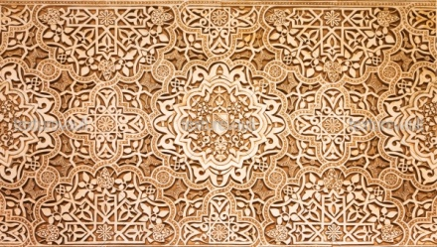
Show-casing the research undertaken by the Centre’s staff, Research Associates and Visiting Researchers and Fellows.
Time | Speaker | Topic
10:30 | Paul Anderson – Assistant Director | A Partial Society: Theorising Inter-Asian Yemeni Merchant Networks
11:00 | Will Ryle-Hodges | Being the Government’s Director of Communications in Late 19th Century Khedival Egypt: Muḥammad ʿAbduh on the worlds we make with words
11:30 | Emanuelle Degli Esposti – Research Associate | Sectarian Belongings: Towards a European Shi’ism?
12:00 | Nor Haslina Jafaar – Visiting Researcher | A framework of approaches to the Islamic principle of multicultural street design that shapes the street characters
12:30 |  | Lunch and displays in the Common Room
14:00 | Arafat Razzaque – Research Associate | Islamic Ethics from Medieval Society to the Modern Family
14:30 | Mehrunisha Suleiman – Research Associate | Muslim perspectives on End of Life Care
15:00 | Khaled Fahmy - Director | The Egyptian military in the 1967 Arab-Israeli War

Lunch will be provided in the Common Room with vegetarian and gluten-free options available. There will also be a static display of the research from several of our speakers.

